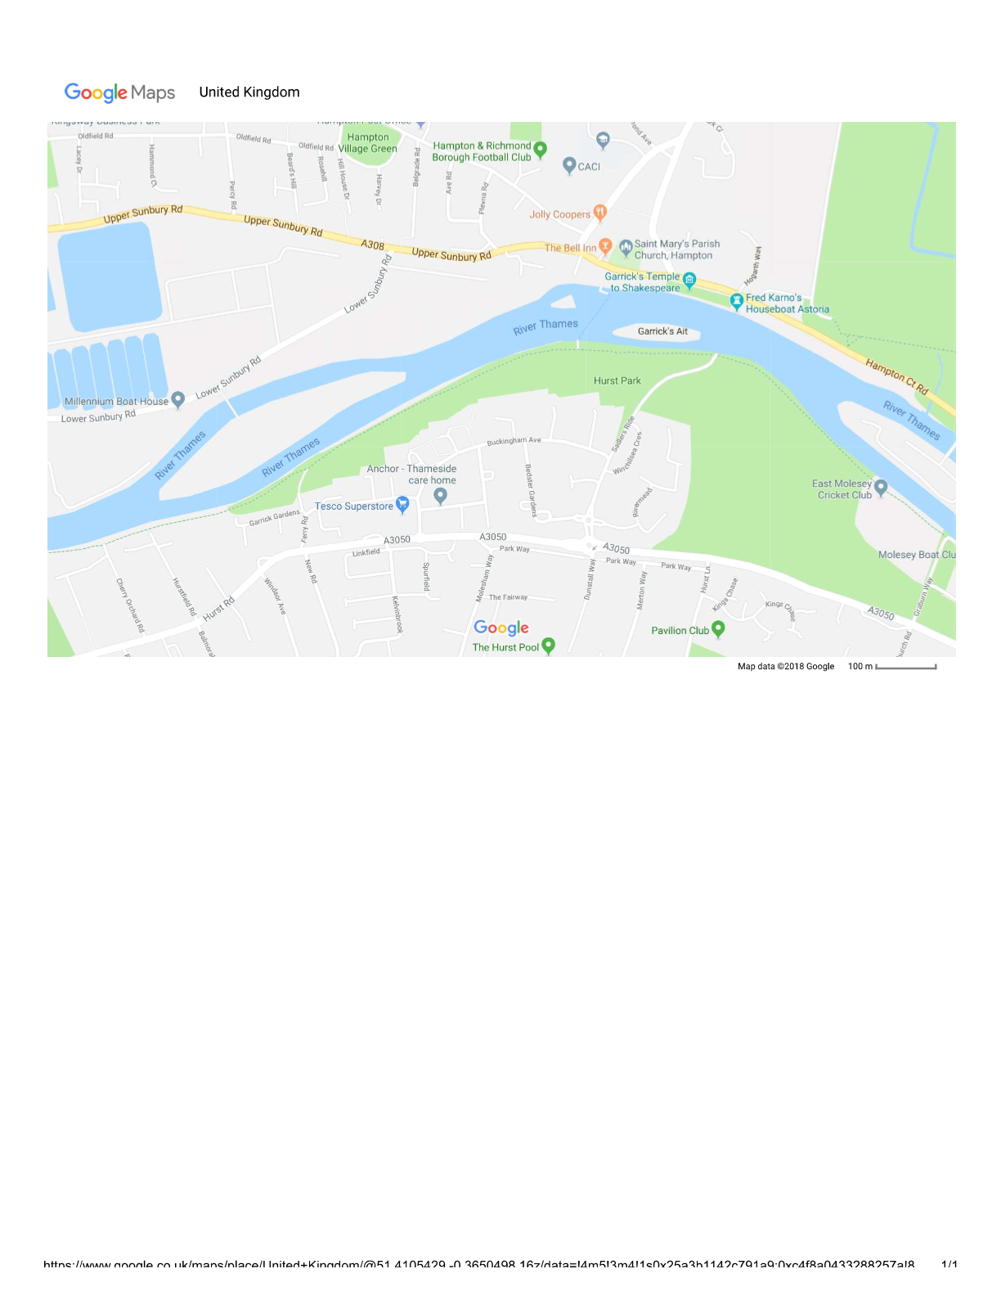
Cars
Trailers
Your text
Cars

