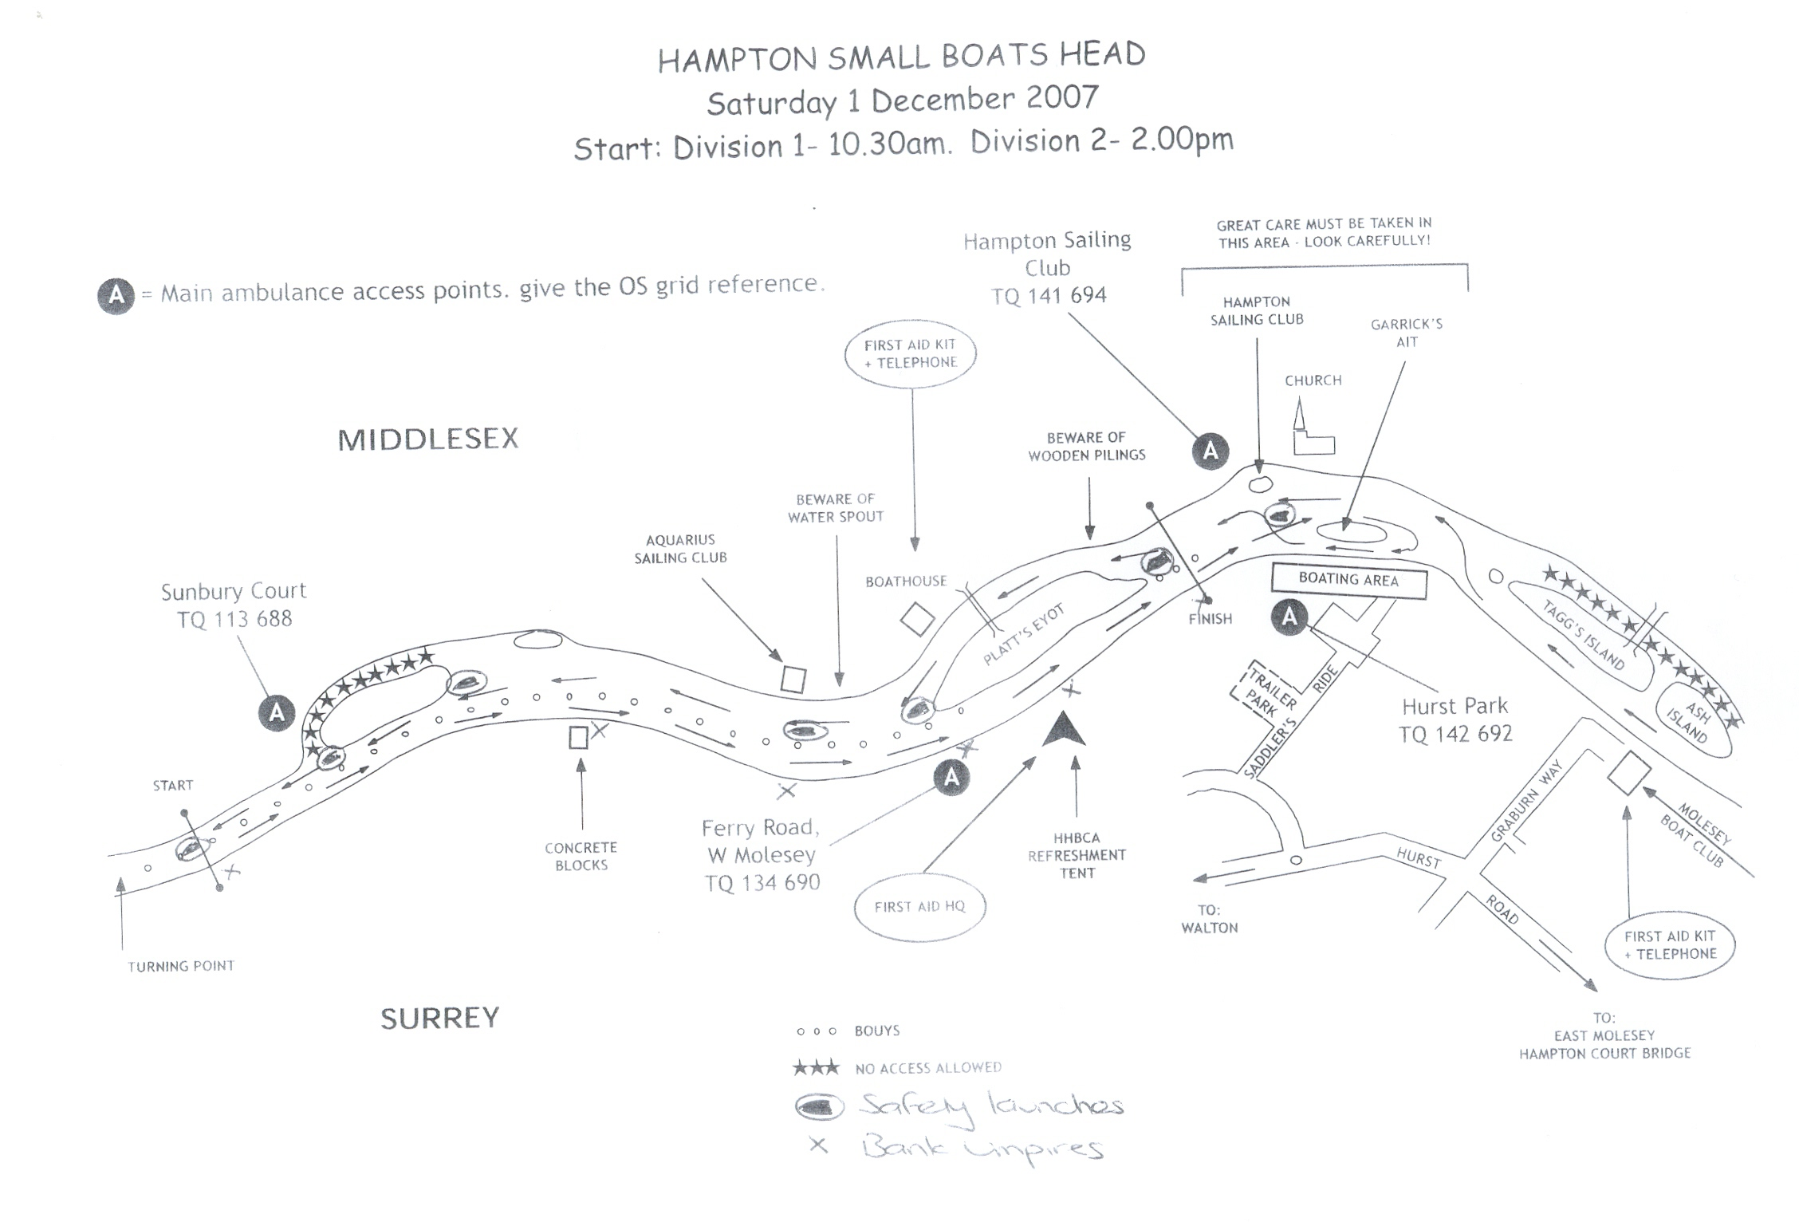
Safety Boat
Safety Boat
Safety Boat
Safety Boat

U1
HAMPTON SBH
SATURDAY 29 November 2025 START: 9.30 and 13.30

