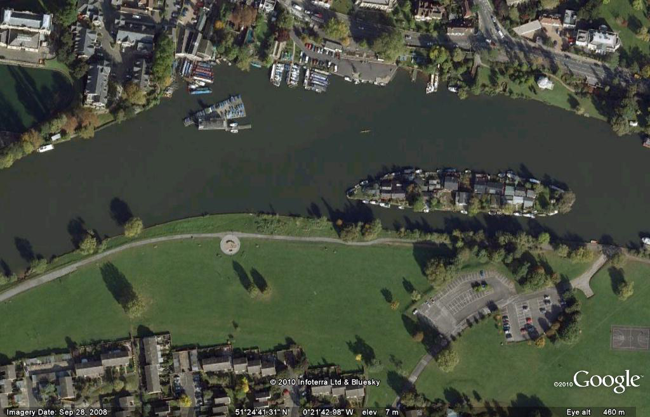
SADDLERS RIDE: BOATING AREA
CREWS RETURNING TO SADLERS RIDE rrrRRIDERIDE
M
M

M
…TO MILLENNIUM B/HOUSE & SUNBURY LOCK
…FROM THE FINISH

